|  |  |
| --- | --- |
| A close up of a logo  Description automatically generated  main Project  Client-Side Experience  UBCO’s Leftovers Club Website | Veronica Jack (12304986)  Katrina Martel (21541164)  COSC 360 Web Programming |

Table of Contents

Introduction 2

Club Information 2

Motivation 2

Logic Process 2

Types of Users 2

Site Map 3

Page Layouts 5

Three-Column Layout 5

Two-Column Layout 5

Walkthrough with Screenshots 7

index.html 7

volunteerForm.html 10

foodDonorForm.html 12

events.html 14

about.html 15

createFoodPost.html 15

memberList-volunteer.html 16

createEvent.html 16

memberList-admin.html 17

viewAccount.html 17

login.html 18

forgotCredentials.html 18

getCredentials.html 19

HTML, CSS, JavaScript, and Images 20

Moving Forward with a Server 20

# Introduction

## Club Information

The Leftovers Club here at UBCO helps to tackle food waste by collecting items that were to be thrown out, broadcasting through their Facebook page to those on campus so that it can be eaten.

## Motivation

Our goal is to create a website for the Leftovers Club as a central hub for those involved. Although their [Facebook Page](https://www.facebook.com/LeftoversUBCO/) currently suffices for creating events, posts can get buried. This can make it difficult for users to become volunteers and know about posts as they become available. By creating a website, we hope to increase the usability for administrators (i.e., keep track of members), as well as create a positive experience for users.

# Logic Process

When a user visits the Leftovers Club web site, the user is on the website in order to find the location of leftovers, to get details about upcoming and past events, to learn about the club, to donate leftovers to the club, or to apply to become a volunteer.

## Types of Users

Before describing the logic process of each page, it’s important to list the types of users that exist. Each user is one of the following:

1. **Clients**: Users who are not logged in are clients of the Leftovers Club; they want to find leftovers, give the club leftovers, or get more involved as a volunteer or admin. They have the most limited access to the site.
2. **Pending Member**: Once a user applies to become a volunteer, they must wait for an admin to view their application and change their member type before they can log in.
3. **Volunteer**: Volunteers have access to create posts about leftovers, but their access is limited
4. **Admin**: Admins have the most control and access on the site – other than the developer

## Site Map

The following bullet points describe the links on the navigation bar from left to right in the site map. The items in orange are dropdown menus, blue are links seen on the main nav bar, green are links either in a dropdown menu or accessible on its parent page, and grey is accessible only on its parent page.

**Get Involved** (dropdown menu in navbar and a side bar)

* Link to Index/Home/Find Leftovers
  + Displays posts about where leftovers can be found
  + Volunteers logged in can create and edit posts
  + Admins logged in can create, edit, and delete posts
* Link to Volunteer Form
  + includes volunteer application form and create an account
* Link to Donor Form
  + Form to fill out if the user has leftovers to give to the club to distribute

**Events** (in navbar)

* lists upcoming and past events with details
* Admins can create, edit, and delete events

**About Us** (in navbar)

* Describes origin and purpose of the club and how to contact the club

**Volunteer** (dropdown menu in navbar and seen only when a volunteer is logged in)

* Link to Create a Post
  + Form that enables a volunteer to create a post on the home page about where clients can find leftovers
* Link to Member List
  + Lists a limited view of all members in the club

**Admin** (dropdown menu in navbar and seen only when an admin is logged in)

* Link to Create a Post
  + Form that enables an admin to create a post on the home page about where clients can find leftovers
* Link to Create an Event
  + Form that enables an admin to create an event on the Events page
* Link to Member List
  + Lists all members in the club with options of editing and deleting

**My Account** (in navbar and seen only when a user is logged in)

* Allows users to update their information (profile picture, email address, phone number, password. Usernames will not be allowed to be changed).

**Log In / Log Out** (in navbar. The displaying button depends on if the user is or is not logged in)

* The logout button logs the user out of the site and navigates the user to the index
* The login page has a form asking for the user’s username and password
* **Forgot Credentials** (link on login page)
  + allows users to fill out a form that asks for their email, security question, and security answer. If filled out successfully, the user’s credentials will be displayed on the **Get Credentials** page

# Page Layouts

## Three-Column Layout

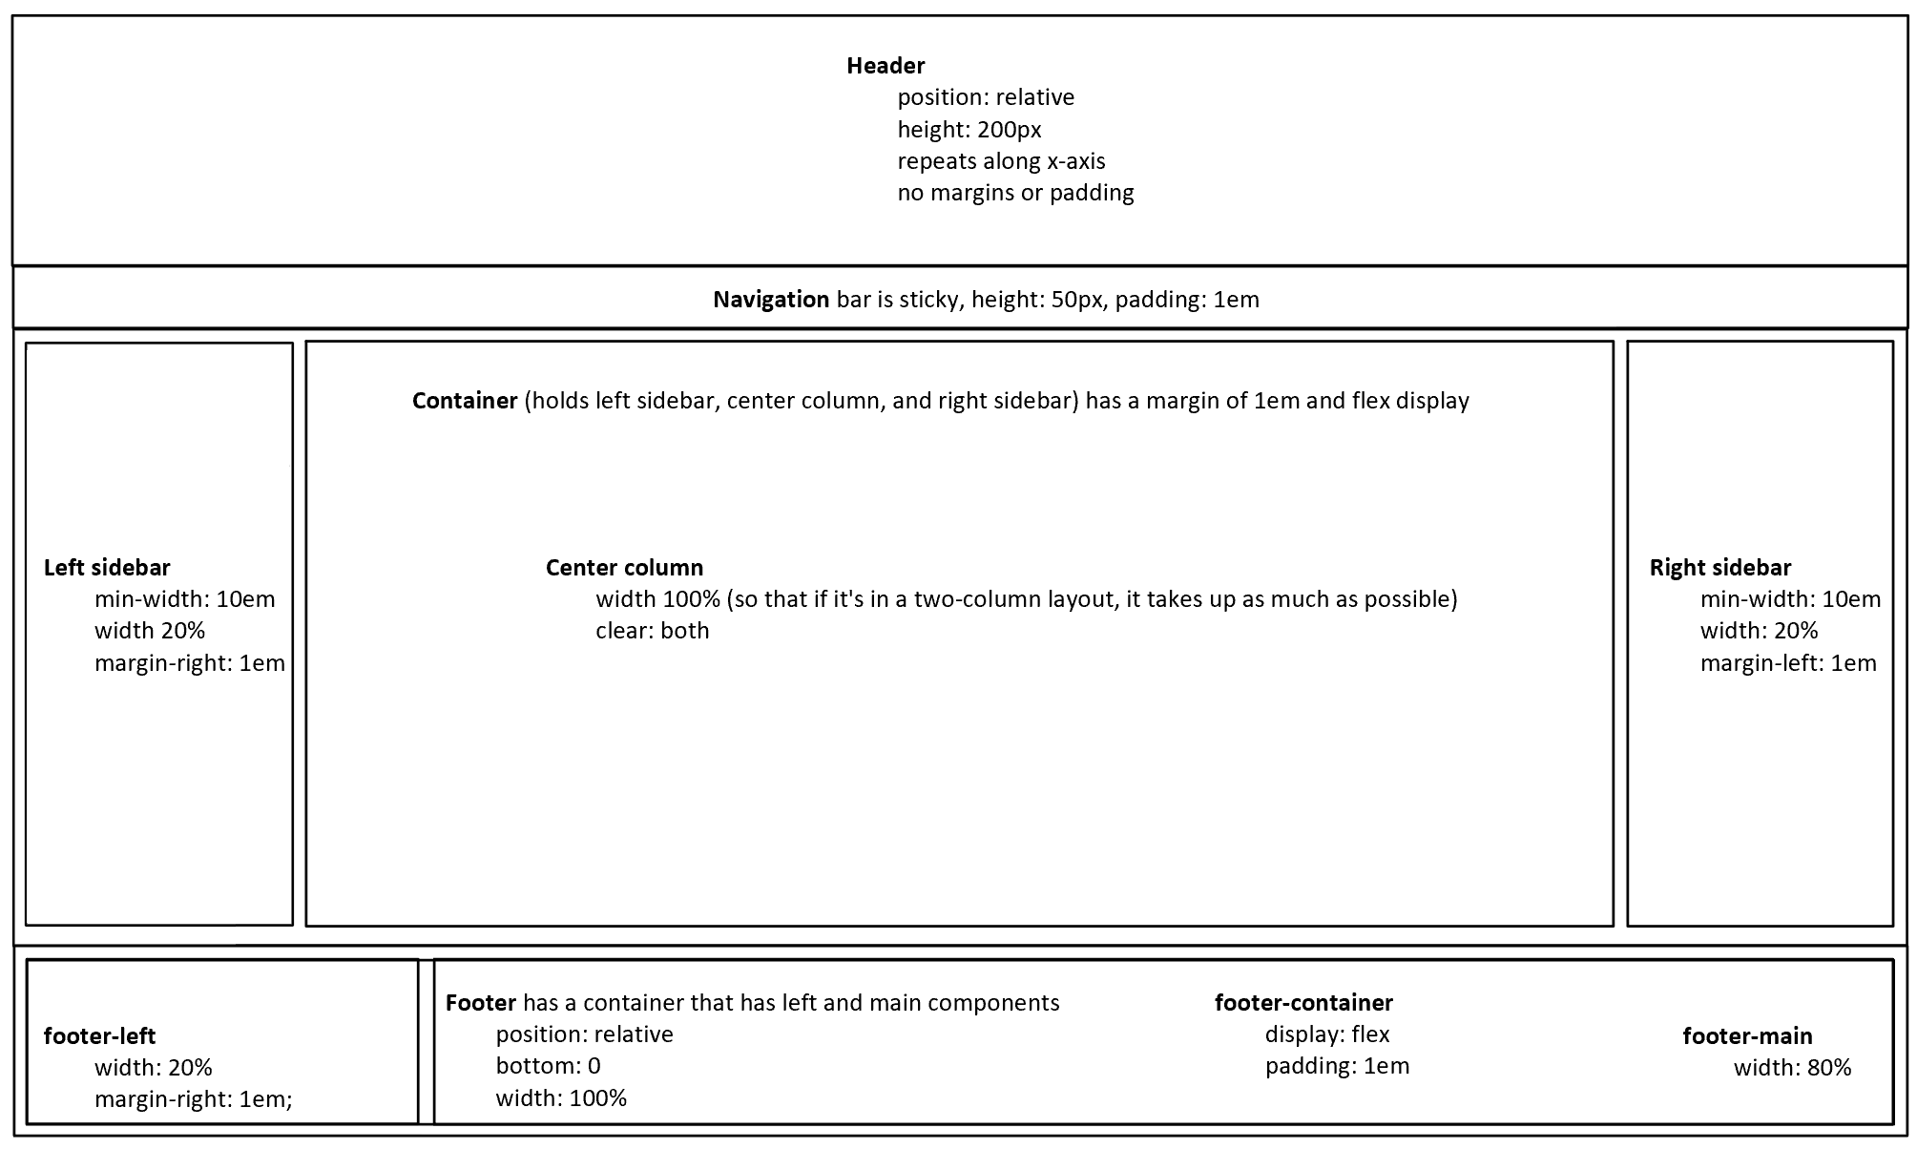

## Two-Column Layout

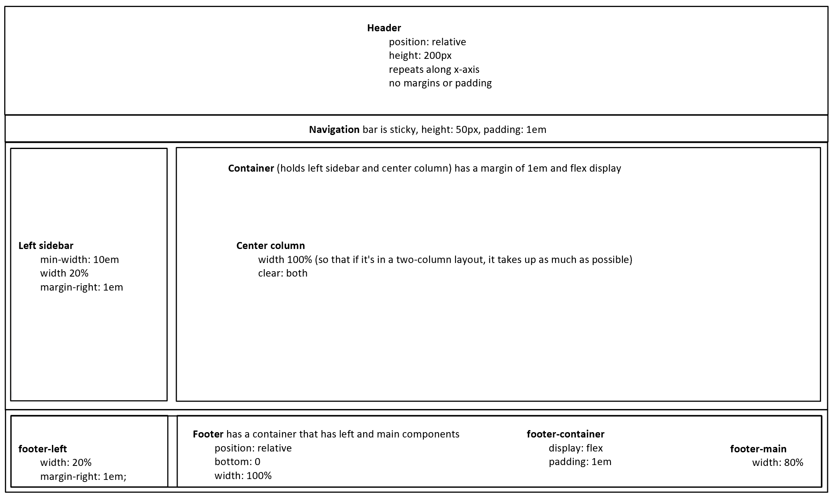

These are the two main layouts. The contents will be described in each page description below. The various views for the headers and right sidebar are currently stored in .txt files. Once we have our database running, depending on the type of user (volunteer or admin), the functionality will change.

Before describing each page, it’s important to note that the website has a responsive design so that when the screen or browser width is less than 760px, the website’s layout changes and becomes easier to view and use. The navigation bar’s main list of links becomes a dropdown menu from a menu icon. The main container has a flex display, so the left sidebar displays on top, the center column is second, and the right sidebar displays under the center column. The footer’s container also has a flex display, and the contents within the footer components wrap.

The elements that have the same layout on each page include: the header, which contains the same image; the navigation bar, which contains the main links the user will use; and the footer, which contains related pages and other footer content.

The left sidebar is located on every page that a client sees. It contains the club’s logo, the main objective of the club, the estimated amount of food saved, the event’s next event, and social media links. The only page where the left sidebar is not showing is the member list page that is for volunteers and admins only.

The right sidebar is located on every page that a client sees. It contains the Get Involved dropdown menu as a sidebar as a way to ensure the client will find the three main reasons for visiting the website. When the user is logged in (as a volunteer or an admin), the My Account page is the only page that does not show the right sidebar; this uses the two-column layout.

# Walkthrough with Screenshots

## index.html

* The index is also known as the homepage and where the “Find Leftovers” links go.
* This is what a client (user who is not logged in) can see
* The first two screenshots illustrate the header, navigation bar, content, and footer. The third screenshot shows the “Get Involved” dropdown menu.

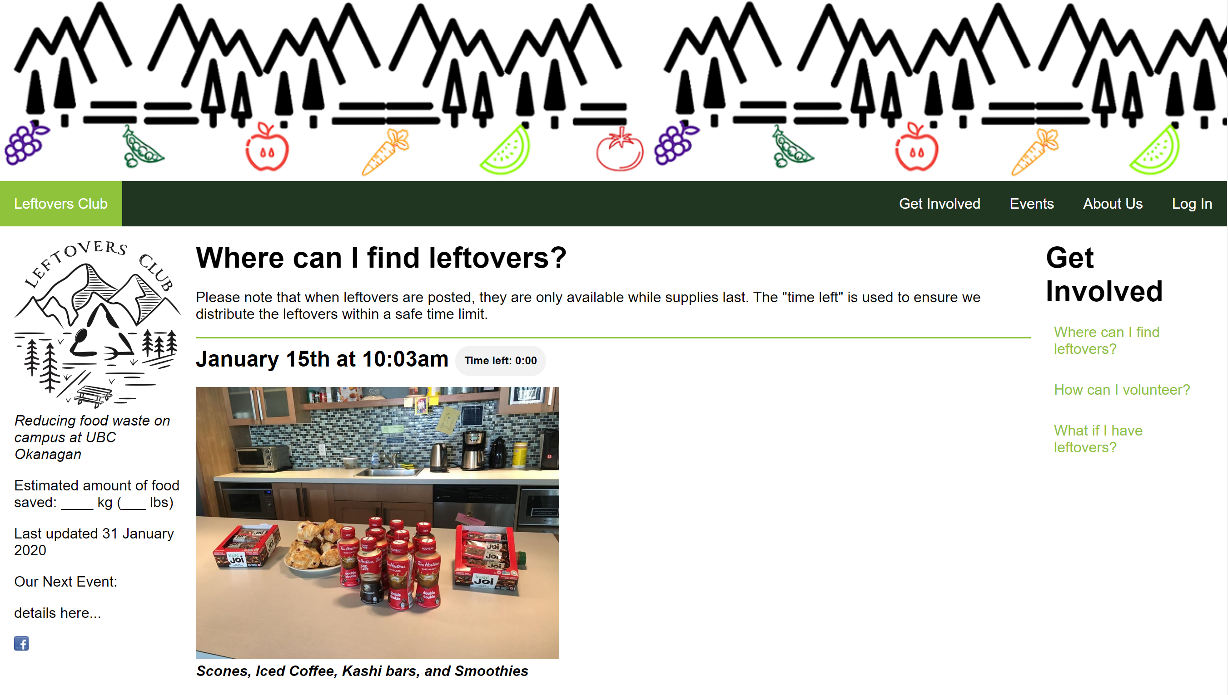

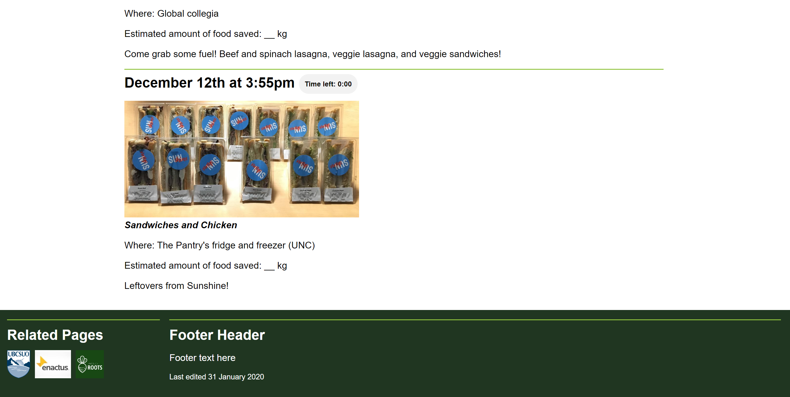

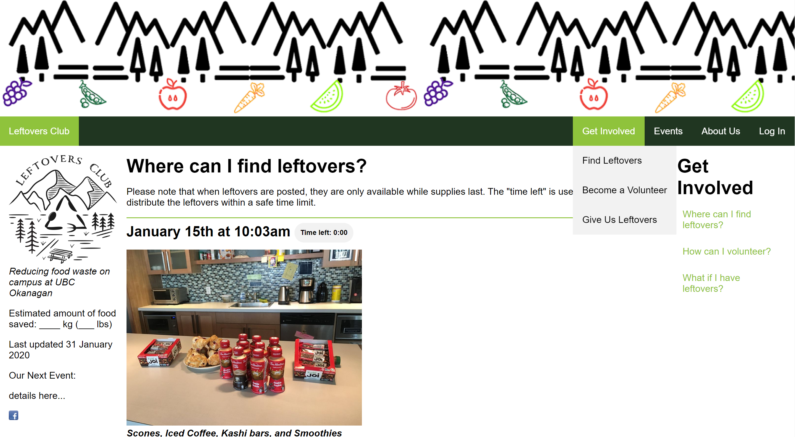

The center column contains:

* Header <h1>
* A disclaimer to users <p>
* Posts <article> that consist of:
  + Date/time posted with a freshness countdown <h2>
  + An image of the leftovers with a list of the items <figure> and <figcaption>
  + The location of the leftovers
  + The estimated amount of food saved (optional)
  + A short message

When a volunteer logs in, the header changes to show the “Volunteer” dropdown menu, the “My Account” link, and the “Log Out” button instead of the “Log In” link. The right sidebar also changes by getting rid of the “How can I volunteer?” link (this is the same for admins).

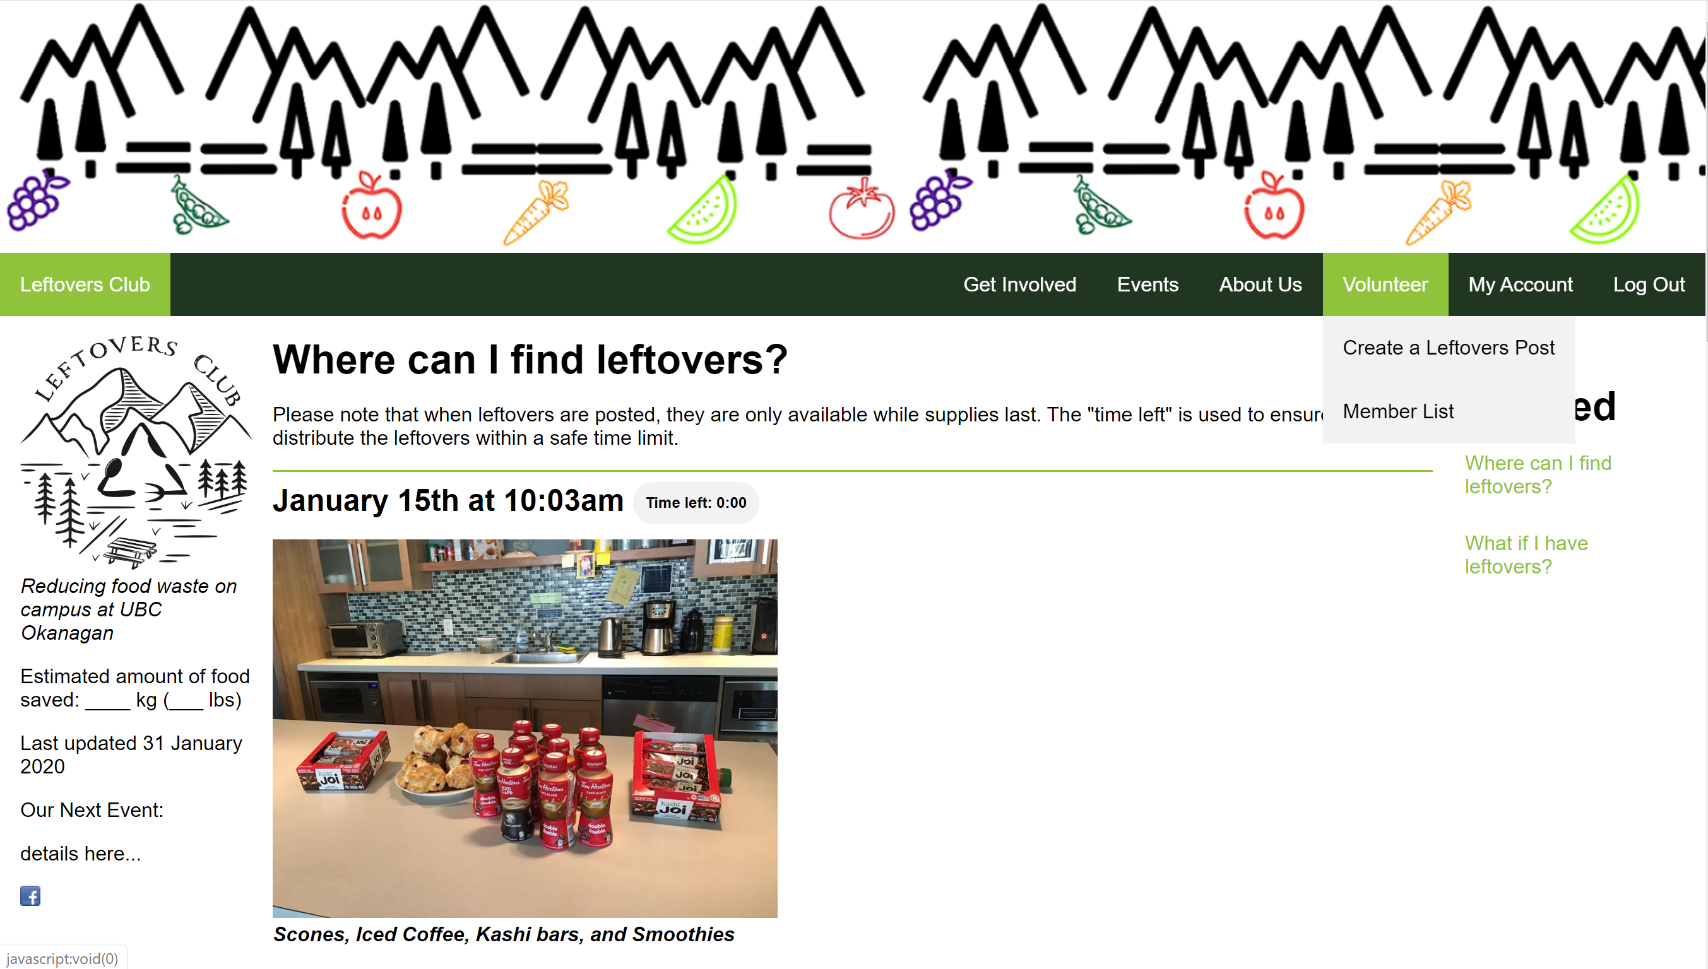

When an admin logs in, the header changes to show the “Admin” dropdown menu, the “My Account” link, and the “Log Out” button instead of the “Log In” link.

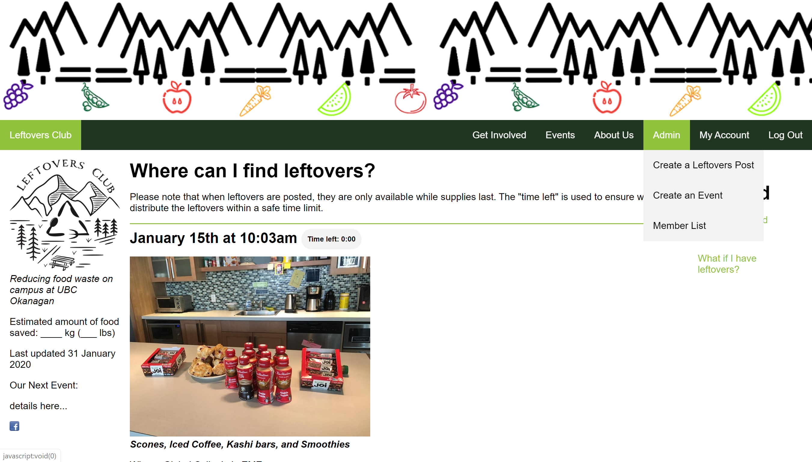

## volunteerForm.html

HTML required fields are used rather than JavaScript since it points out directly on the field what’s to be inputted, rather than using an alert. The volunteer page is split into two sections:

1) The volunteer application form

* + Users are required to enter their name and why they want to volunteer

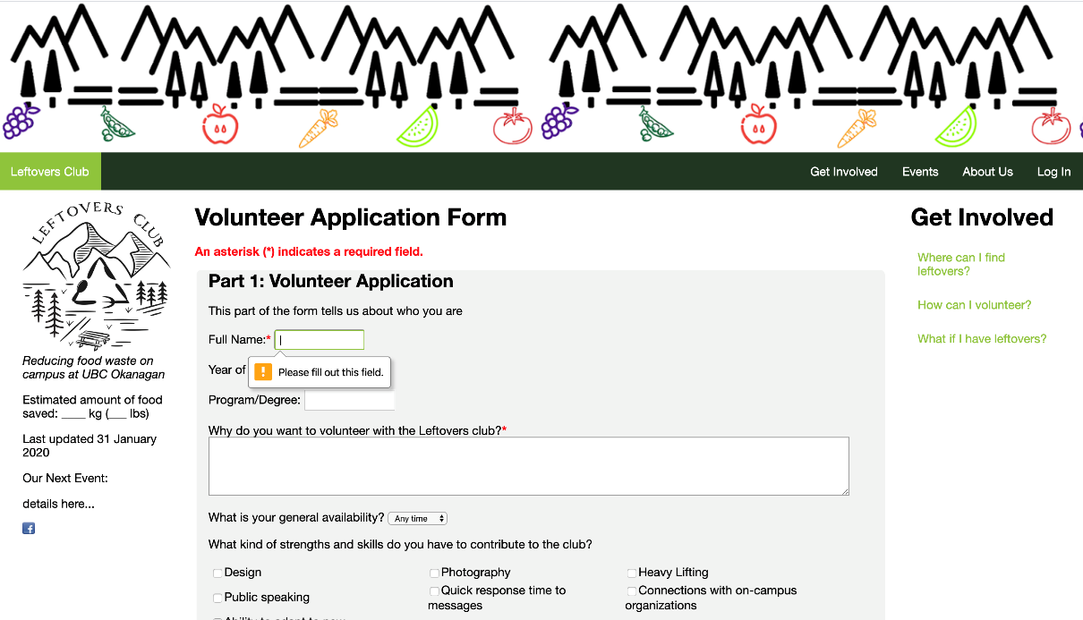

2) Users create an account

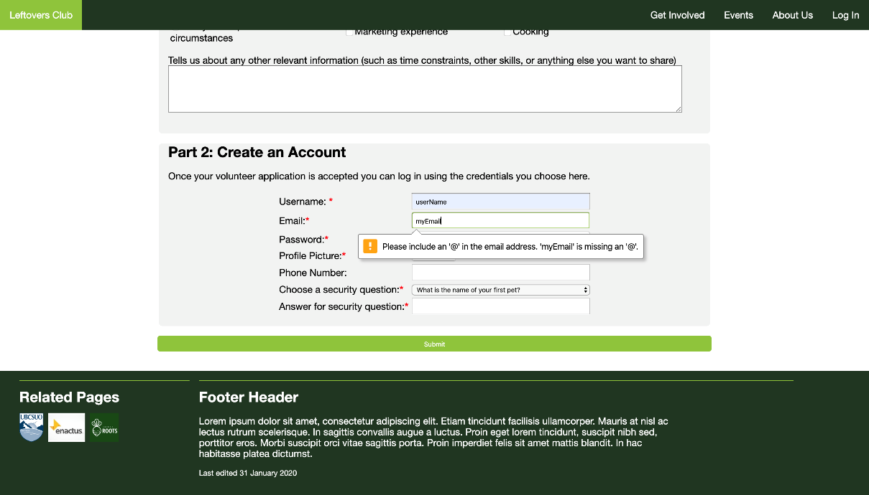

Once a user has filled out the form correctly, they’re redirected to the home page.

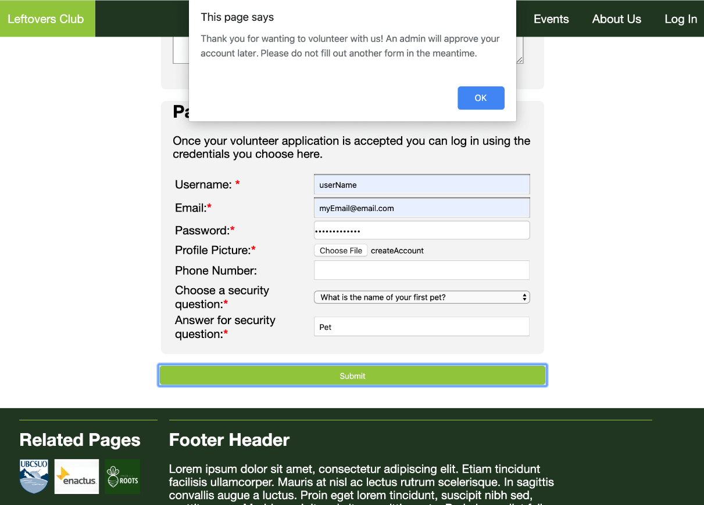

Only when an admin has approved a volunteer’s account can the user login. If they try to login before their account has been approved, an alert will popup notifying them that their account has yet to be approved. This will be implemented once we have access to the database.

## foodDonorForm.html

Trusted donors are required to fill out certain fields of the form. Once all required fields (denoted by an asterisk) have been entered, the user is returned to the home page.

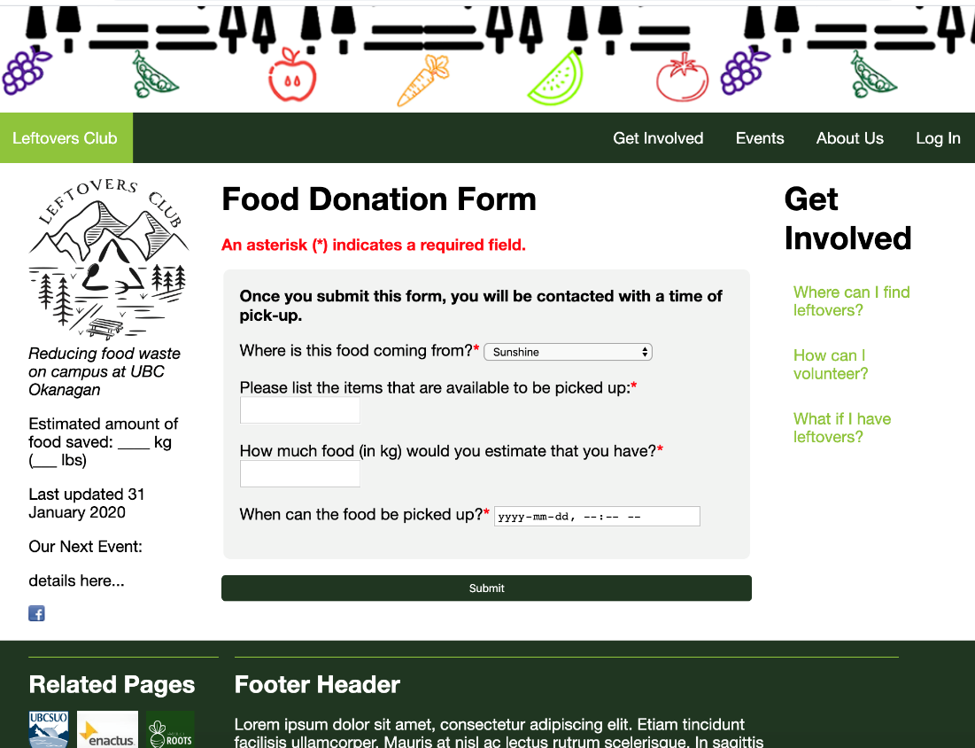

If the user selects “On-Campus event”, two new text fields appear.

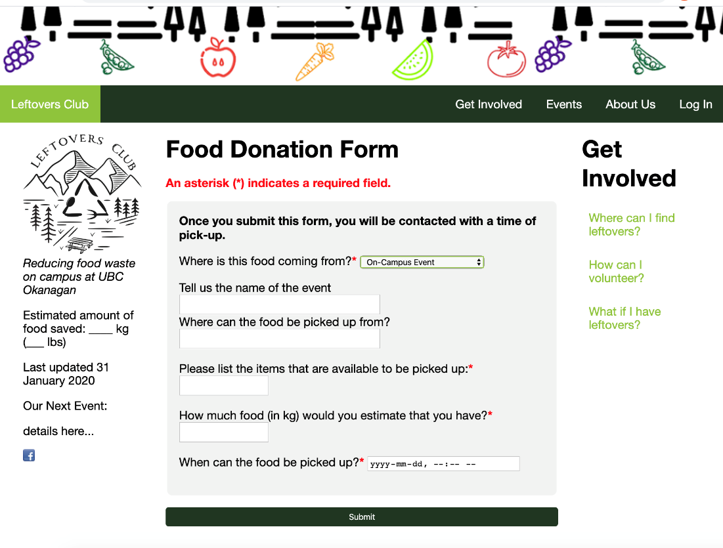

If the user selects “Not Listed as a trusted donor”, they’re encouraged to email the Leftovers Club

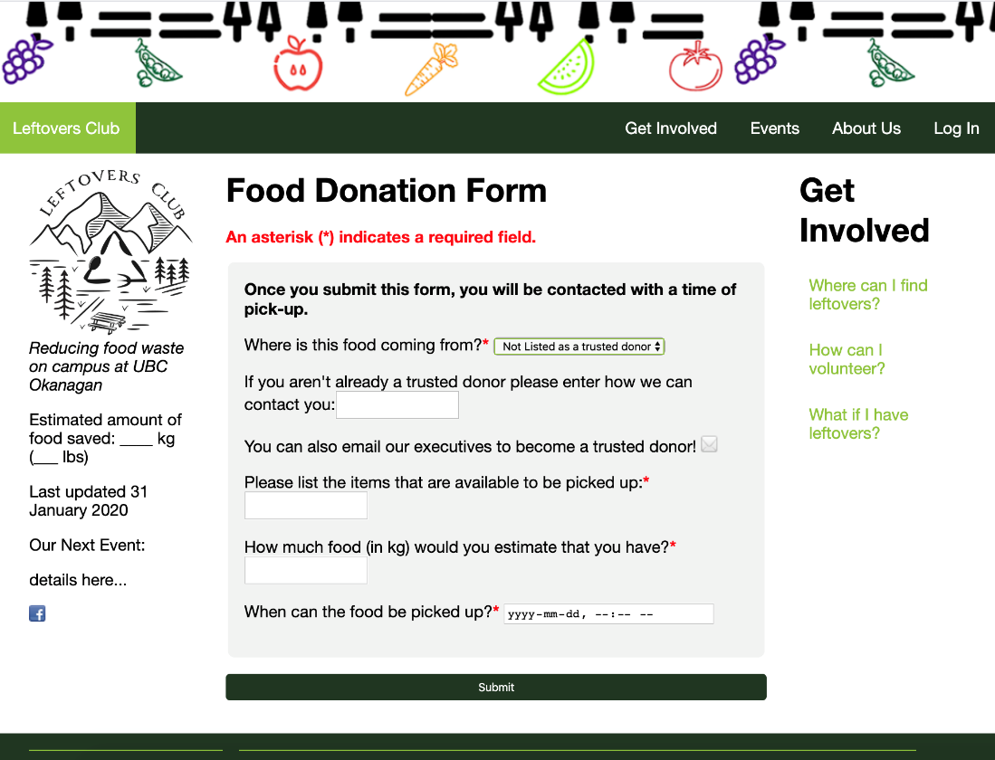

JavaScript validation is utilized within foodDonorForm.html to incorporate the dynamic text fields for donors not listed as well as donors from on-campus events.

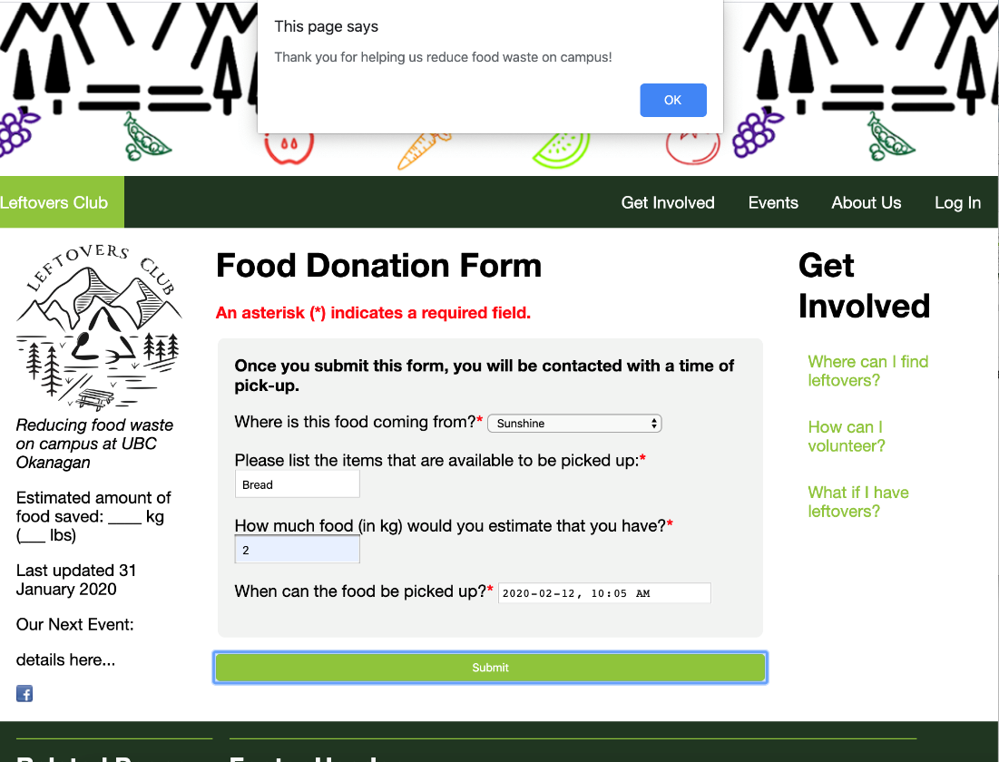

## events.html

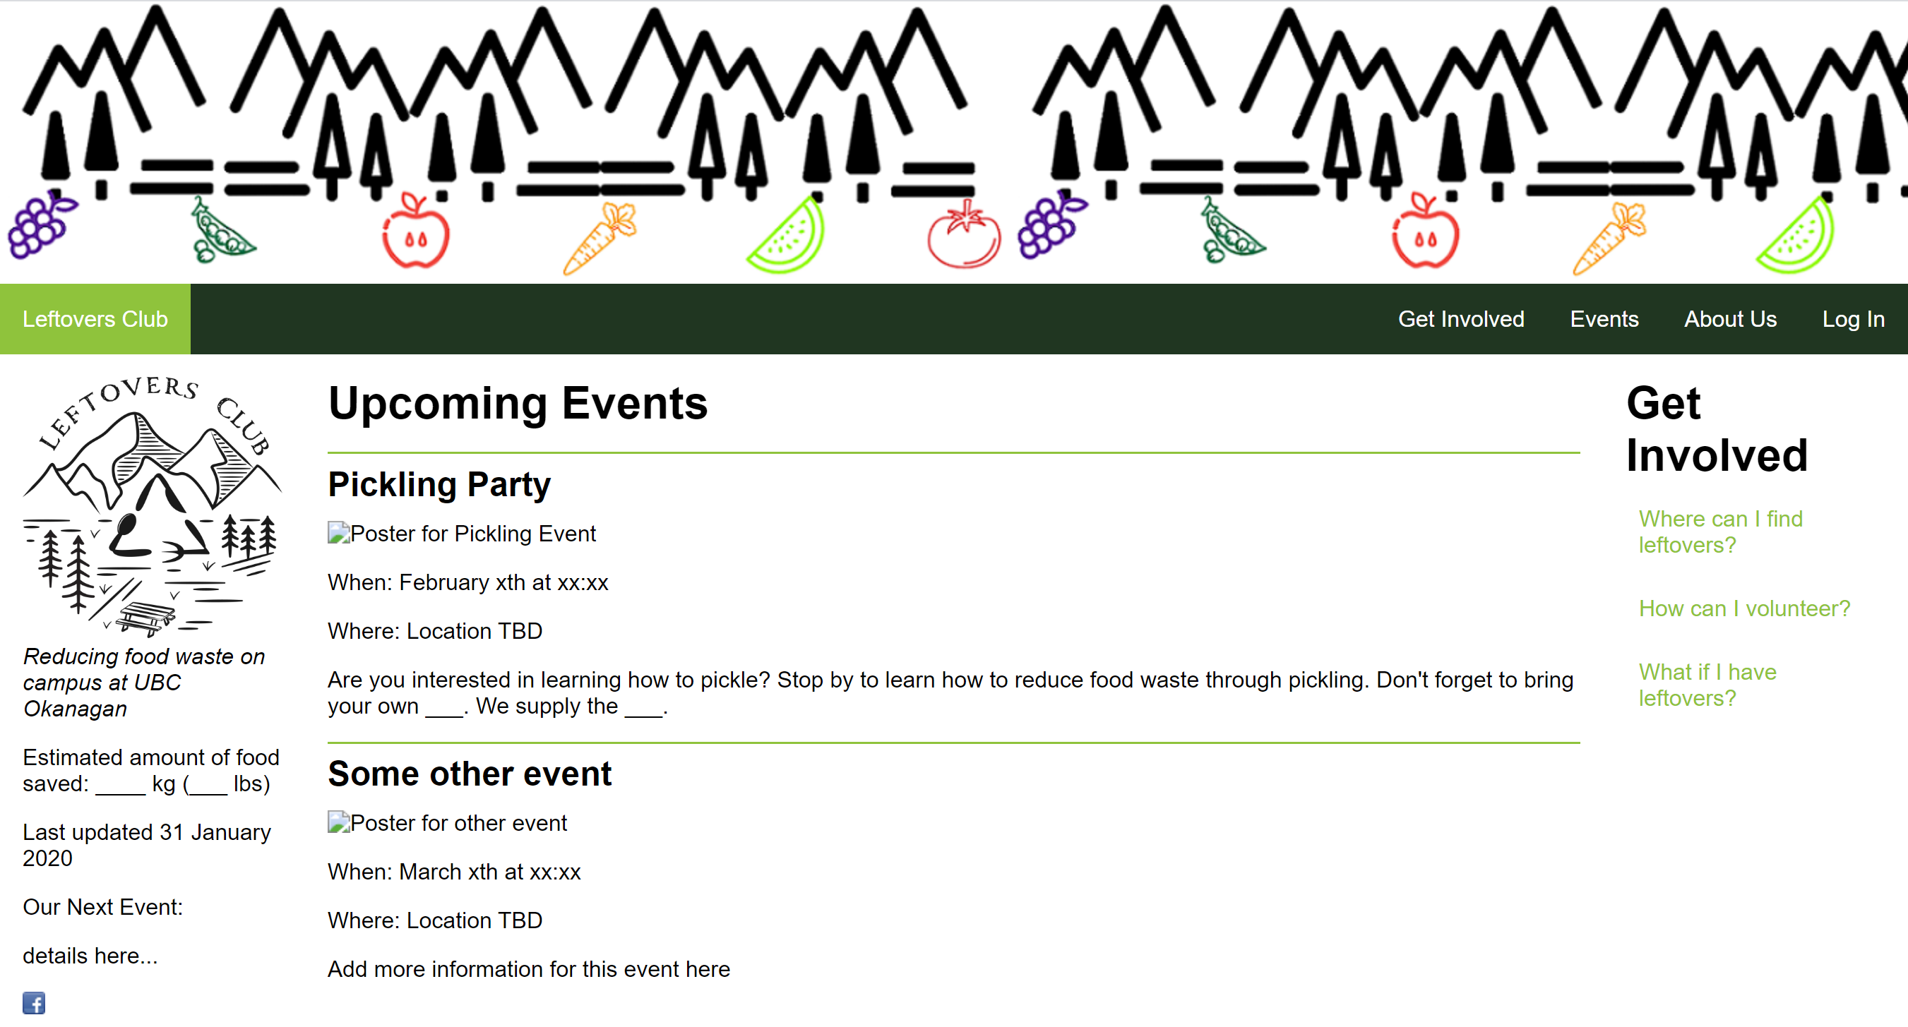

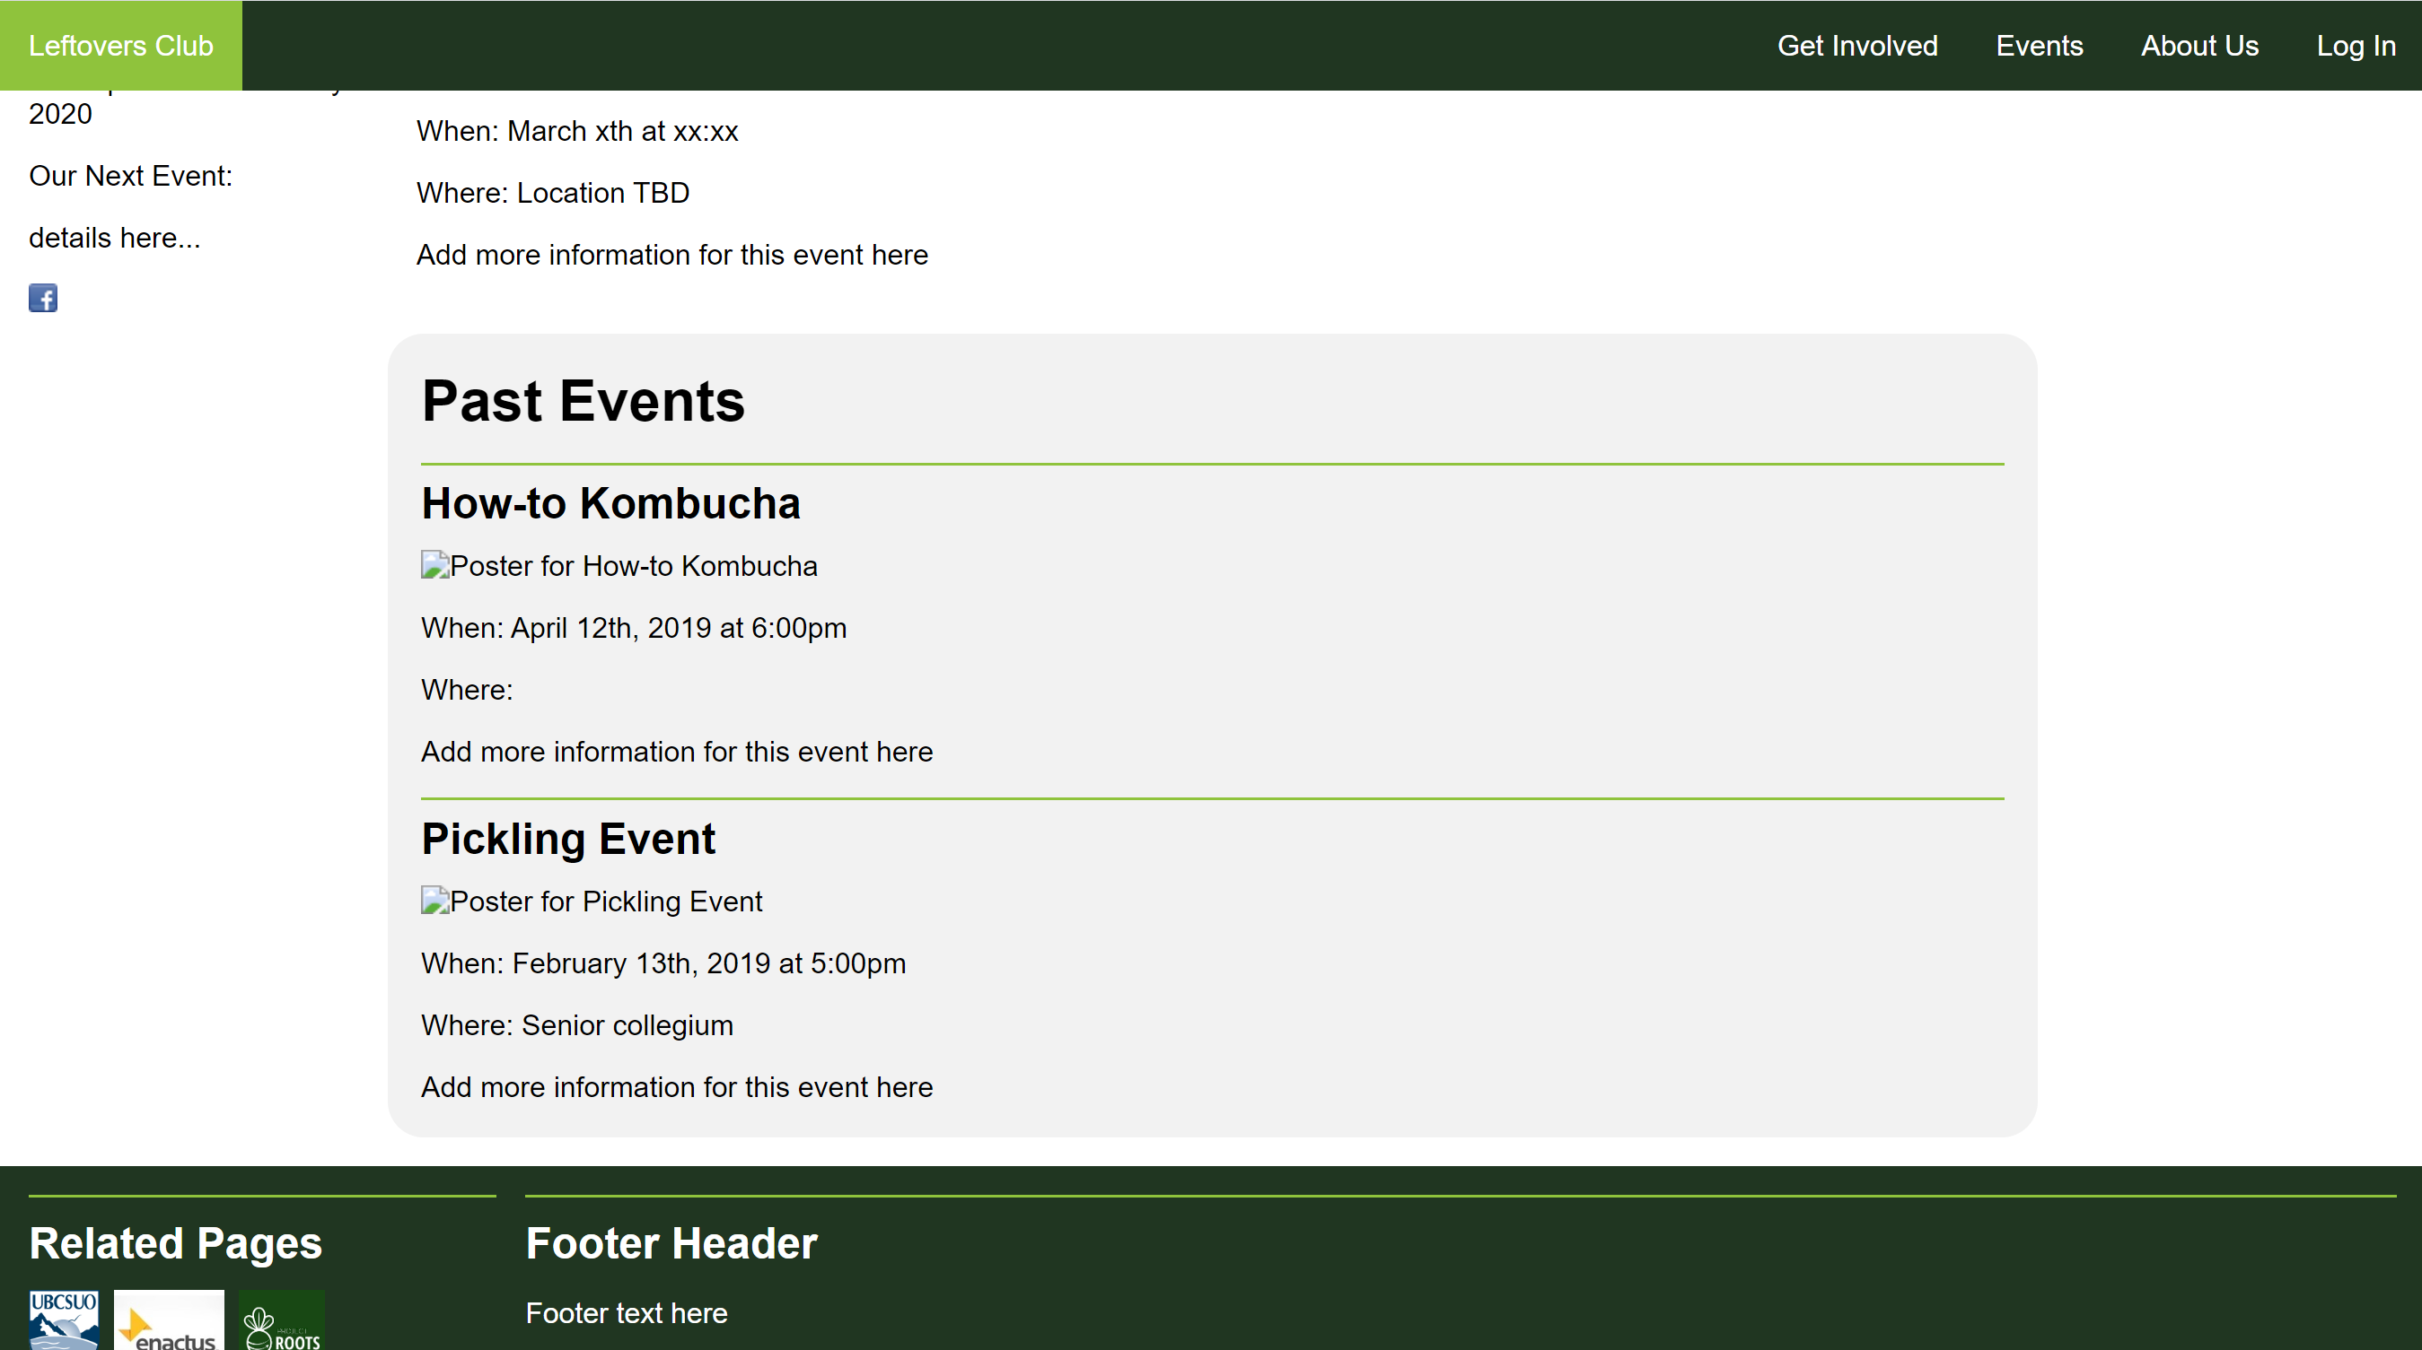

The center column contains:

* Heading <h1>
* Upcoming and Past Event Sections <section>
* Events <article> that consist of:
* Event name <h2>
* Event poster <img>
* Event details <p>

## about.html

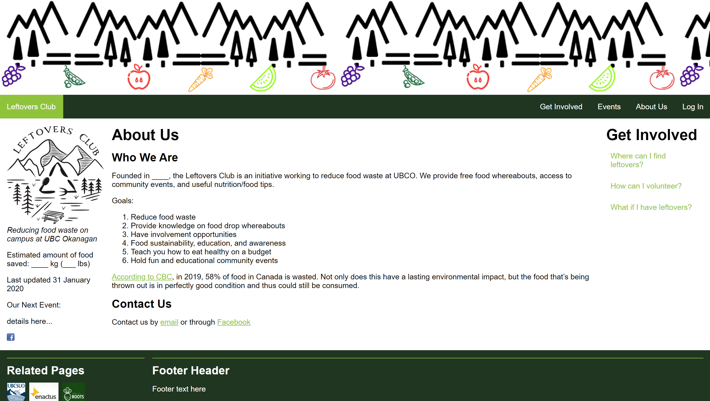

The center column displays general information about the club:

* About Us header <h1>
* Who We Are header <h2> with content
* Contact Us header <h2> with content

## createFoodPost.html

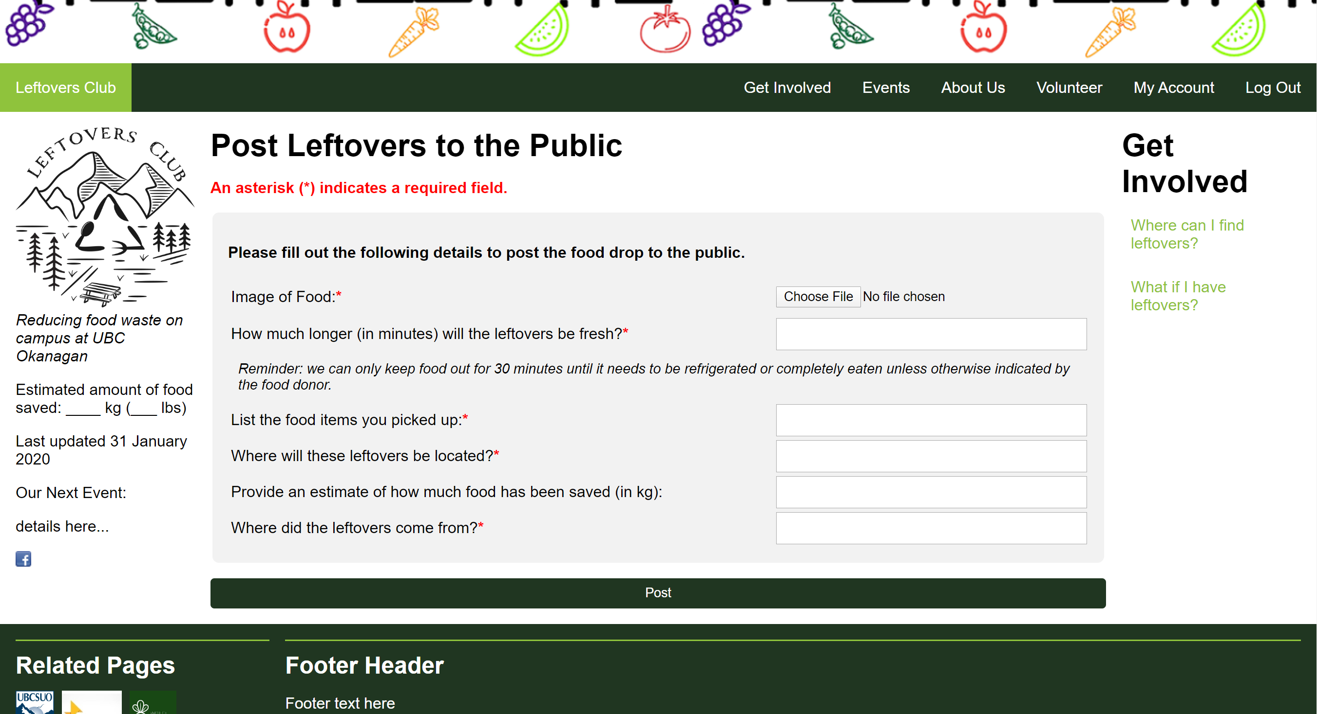

The form’s required and pattern attributes in addition to JavaScript ensure fields are filled in properly before creating the post. Both volunteers and admins can create food posts.

## memberList-volunteer.html

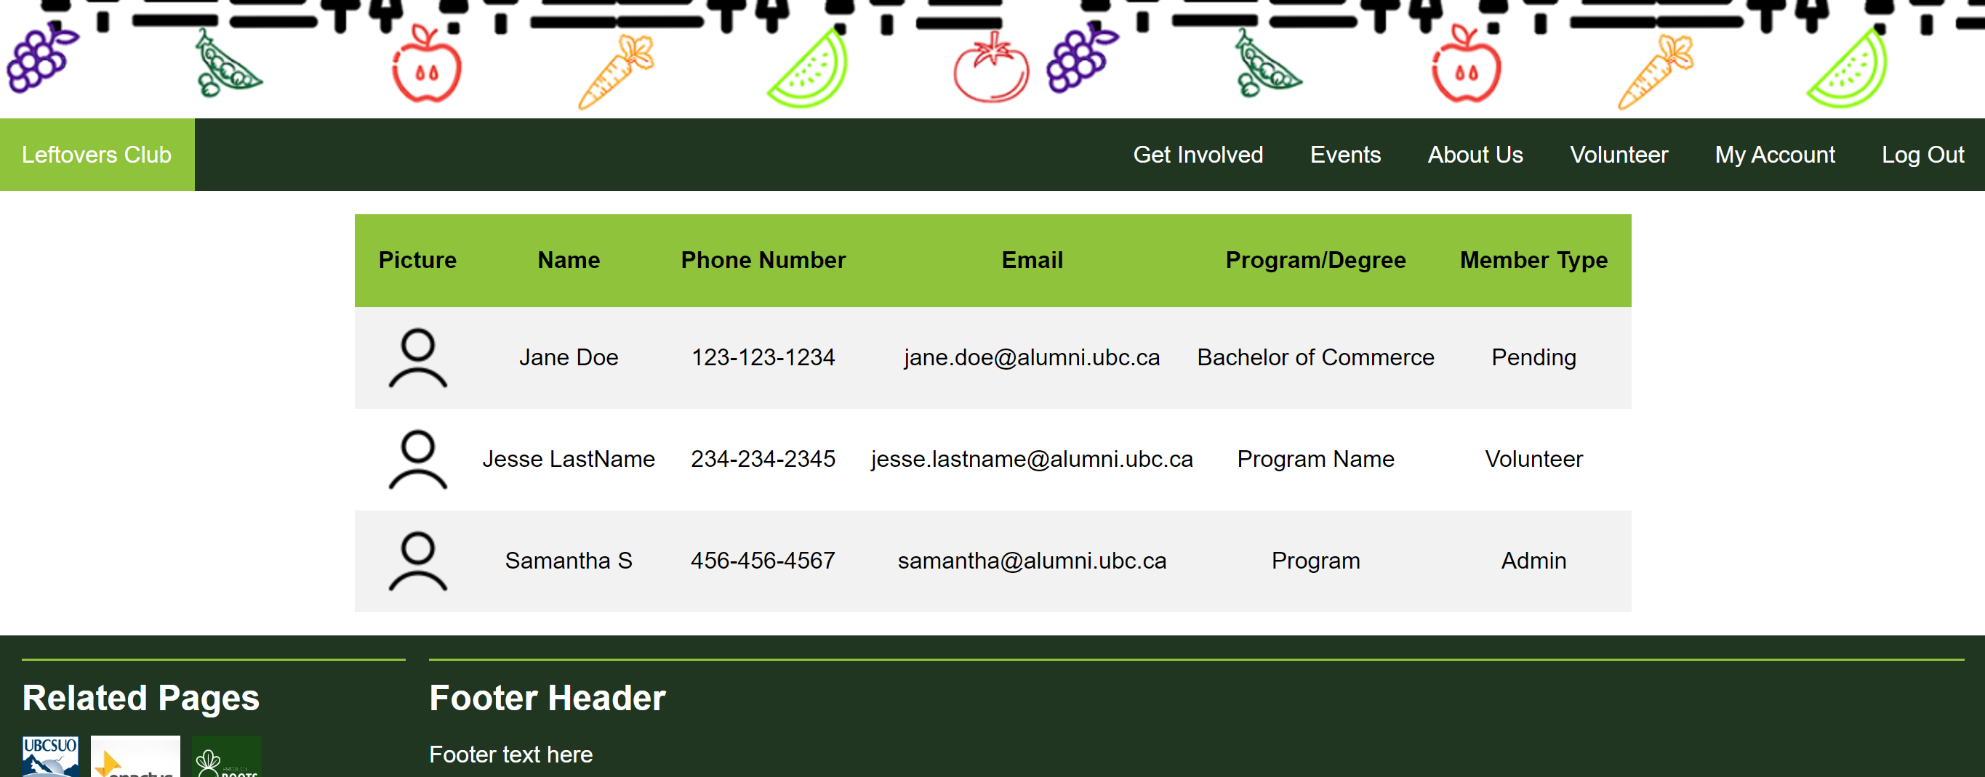

As mentioned above, the member list is the only page without the left and right sidebars, as the content in the member list table can become difficult to read, even with the overflow: auto (enabling scrolling). Volunteers see a limited member list.

## createEvent.html

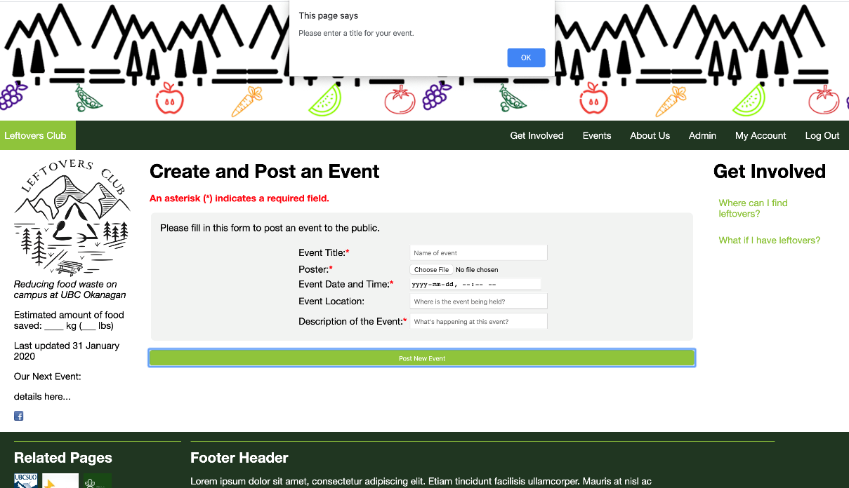

The form’s required and pattern attributes in addition to JavaScript ensure fields are filled in properly before creating the post. Both volunteers and admins can create food posts.

## memberList-admin.html

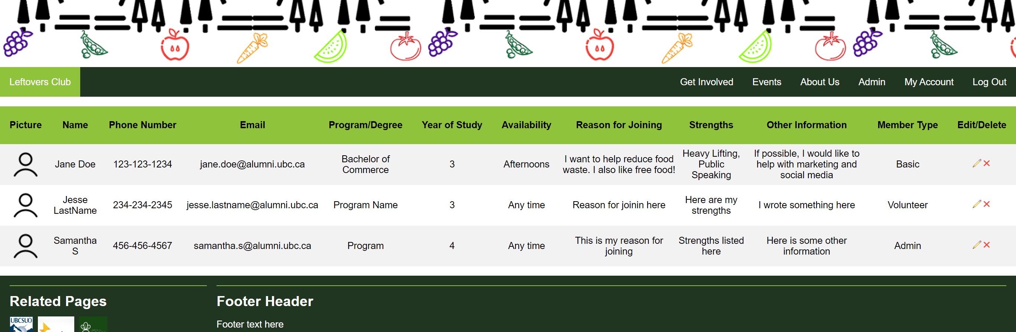

As mentioned above, the member list is the only page without the left and right sidebars. This is because the content in the member list table can look cramped even with the scrollbar enabled. Therefore, the sidebars were taken out to allow a more enjoyable user experience.

Admins have full access to the member list and can edit or delete the members.

## viewAccount.html

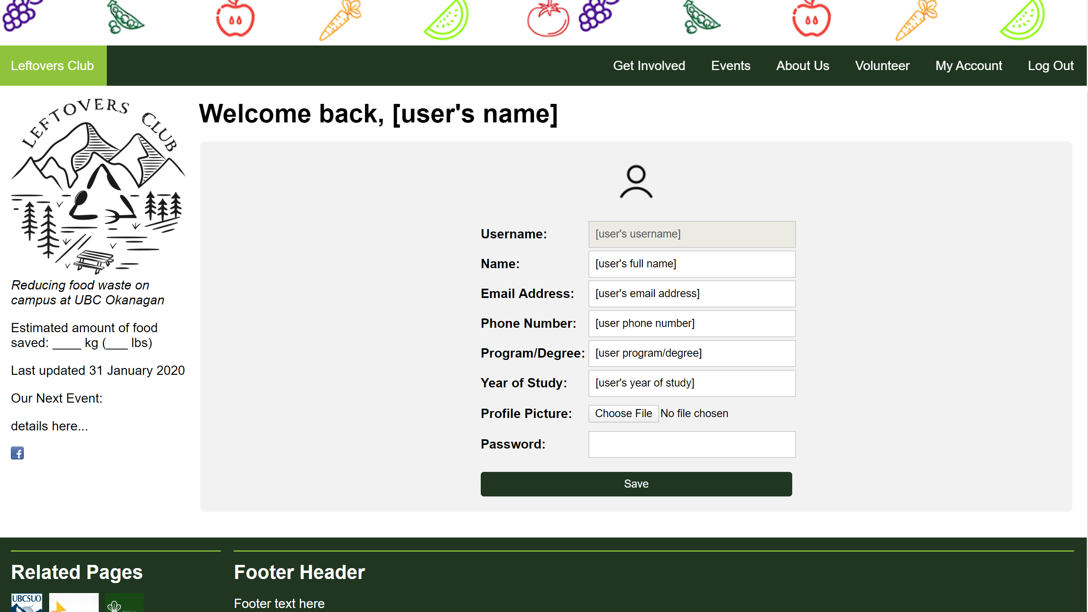

Using the two-column layout, this form allows users to edit their account information that they inputted when they first created their account. The username input field is disabled so that users cannot change their username. This page currently serves as a placeholder. Once we have access to the database, we will be able to retrieve the user’s information so that it can be edited. Before saving any changes, the user must input their password as an extra level of security.

## login.html

Users will be able to login using their credentials stored in the database.

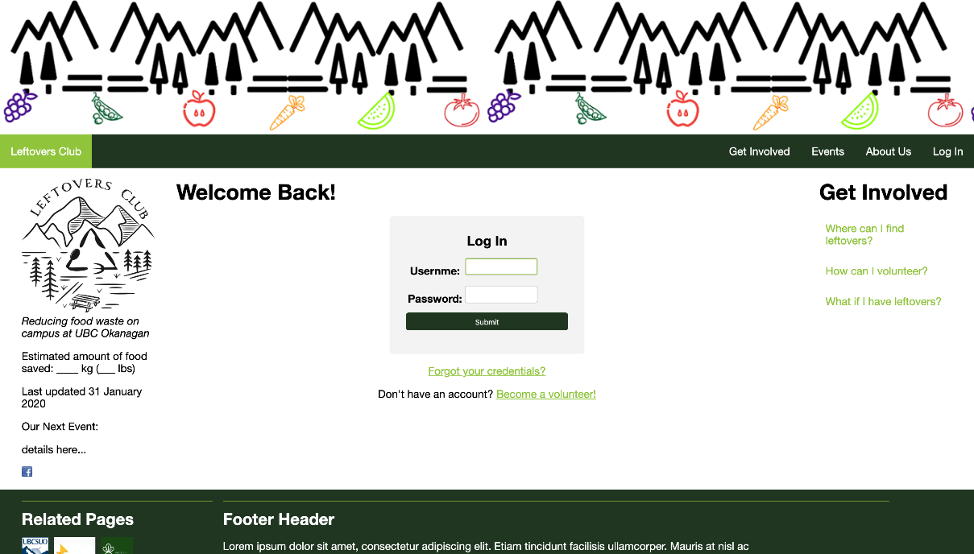

## forgotCredentials.html

Accessible from login.html. The user can choose which information they have forgotten using the checkboxes. The user will provide an answer to their security question. Without a server to send an email, the page redirects the user to the getCredentials.html page.

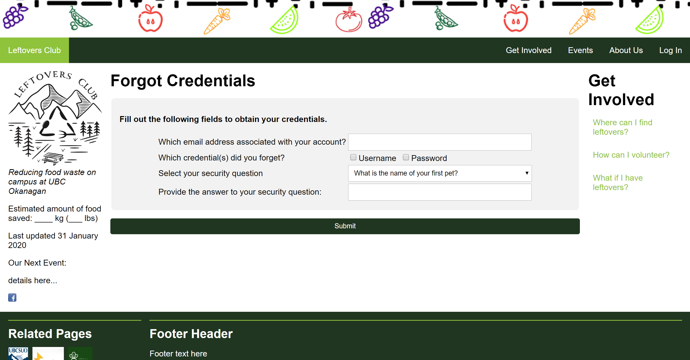

## getCredentials.html

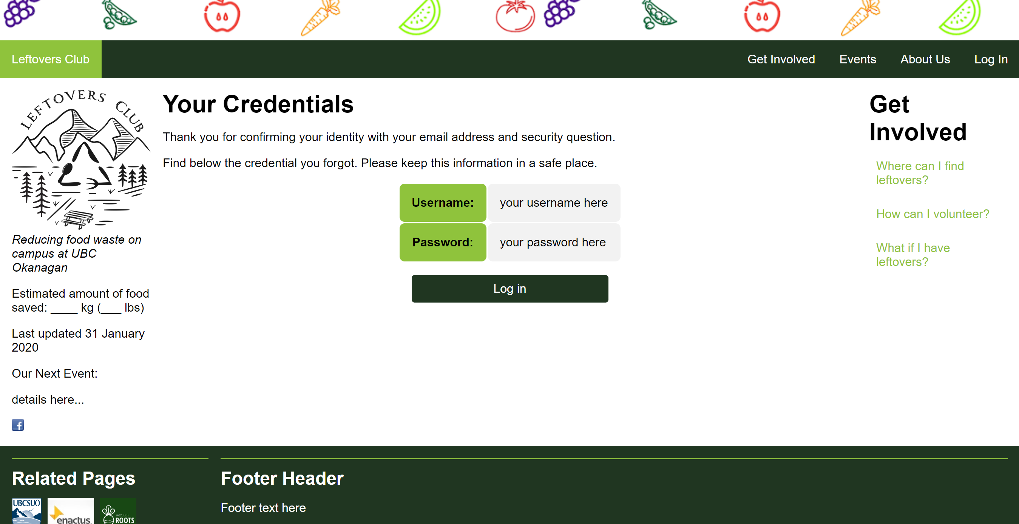

Until the server is set up to send emails to the user with their credentials, the forgotCredentials.html form redirects the user to this page, where the appropriate credential that was indicated as forgotten will show.

# HTML, CSS, JavaScript, and Images

Please see the folder attached to this document submission to find the html pages, css document, image folder, and external JavaScript files.

# Moving Forward with a Server

All information required to create an account will be stored in the database on the server. Queries will be used to allow only volunteers or admins to login (not pending users) and to display the correct heading once a volunteer or admin logs in. Querying will also be used to determine what the member list displays:

* + Clients do not have access to see the member list
  + Volunteers will see a limited member list
  + Admins will see the full member list and be able to edit and delete members

Based off the username of the logged in user, the information stored in the database corresponding to their account will be displayed on the “Account information” page. This can then be edited and updated on the server.

After a food drop has occurred, the server will add the sum of the kilograms inputted in the post, updating the total amount, and displaying the new value on the progress bar.

For security, we can only allow an account to be created if the email doesn’t currently exist within the database. This would prevent individuals creating multiple accounts under the same email.

On the “My Account” page, the server will query for the user’s information, and then the user will be able to edit their information and save it, which will save in the server.

If a user forgets their credentials, they can fill out a the “Forgot Credentials” form. If the right answer is provided, an email will be sent with the corresponding information needed to login/reset their password.